Fish do not need Visas: the transboundary nature of world fished species

DRAFT DO NOT SHARE

Authors: Juliano Palacios-Abrantes1, Gabriel Reygondeau1,2, Colette Wabnitz3 and William W.L. Cheung1

Affiliations: 1Institute for the Oceans and Fisheries, University of British Columbia, Vancouver, Canada, 2Yale University, New Haven, Connecticut, USA, 3Stockholm Resilience Centre, Stockholm University, Stockholm, Sweden

**Notes:**

* Ignore references, they are not formatted
* Figure 2. Labels are to be grouped in 3 categories;
  + “A – Growing “(Equivalent to Developing and Rebuilding);
  + “B – Fishery over 50% of Peak” (Equivalent of Max. Exploitation), and
  + “C - Fishery under 10% of Peak” (Equivalent to Overfished and Collapsed)
* Figure 3. Might change it for top 15 species of each preference or over 30 countries to reduce the amount of species in the plot
* Figures resolution is low and that’s why you can’t read the names properly
* Aiming for *Science* (~2000 words), hence, the format

# Main Article

Species distribution around the world is not a random process. The area in space and time that a species population occupies is a response to the availability of resources, a series of biotic and abiotic factors, as well as their influence on the evolutionary processes [@Hunch]. Marine resource management is predicated on knowledge of species distributions as human-made spatial boundaries are inherent to existing management systems (e.g., marine protected areas) [@Song:2017iua]. However, incorporating the concept of species distribution into fisheries management, or policy, is a relatively recent construct [@Alexa]. The delineation of Economic Exclusive Zones (EEZs) in the early 80s, for instance, virtually established boundaries across the distribution of many species, creating shared species between nations, and adding another level of complexity to fisheries management. Forty years after their formal adoption, the question of how many shared species exist in the world based on their distribution is still unanswered. Fishing quotas set by different nations for a shared fishery resource have led to conflict [@Spijkers:2017ij]. Climate change, which is shifting species distributions, is likely to exacerbate this type of conflict [@Pinsky:2018cb] and presents further challenges for fisheries management (@Mills). Thus, answering the questions of how many shared stocks exist in the world, and where these are located, is critical to developing effective and resilient management plans for the continued and future sustainable use and conservation of marine resources.

From 1973 to 1982, members of the United Nations held a series of meetings to discuss regulations regarding the high seas, a region of international common property, at that time, consisting of waters from 12 miles from shore [@McRaeandMunro1989]. The establishment of the UN Convention on the Law of the Sea (UNCLOS) allowed coastal states to claim jurisdiction over the exploration and exploitation of marine resources over 200 nautical miles off their coasts [@UN:1982]. While intended to improve fisheries management by granting property rights over shared resources, this arbitrary delimitation of management areas was not informed by bio-geography, essentially ignoring species distributions and creating what we know today as shared fish stocks [@Gulland, @Munro2002]. Fish stocks, are comonly refered in fisheries management as a particular population that is more or less isolated from other stocks of the same species and hence self-sustaining [@FAO:1999tk]. The Food and Agricultural Organization (FAO) recognizes three types of shared stocks: (*i*) transboundary stocks, shared by 2 or more neighboring coastal nations; (*ii*) straddling stocks, occurring in two or more adjacent national jurisdictions and the high seas; and (*iii*) highly migratory stocks, found in the EEZs of coastal nations that are not necessarily adjoining, and the high seas. The inception of shared stocks called for the establishment of new fisheries management methods. Managers and scientists adopted a game theory approach – or means to analyze strategic interactions among decision-makers – which demonstrates that collaboration is most likely to result in the best overall outcome for nations sharing a common resource [@Bailey:2010ga,@Eide:2013dh]. Lack of collaboration in shared stocks may threaten stock sustainability [@Clark:1980js; @Nguyen:2018dk], reduce the profitability potential of the fishery [@Merino:2007jz], and lead to conflict between coastal nations [@Spijkers:2017ij], although cooperation and non-cooperation can be more complex [@Jensen:2015cf]. Moreover, under climate change, species distributions will shift [@Cheung2016], resulting in new shared stocks [@Pinsky:2018cb] and highlighting the key role cooperative fisheries management can play in maintaining stocks and profitability [@Nguyen:2018dk] as well as hopefully reducing fisheries conflict [@Spijkers:2019cz].

There is a gap in assessing the nature and number of transboundary species in the world based on their spatial distribution. Caddy [@Caddy:1997ue] in 1997 estimated that there could be up to 1,500 transboundary fish species in the world. However, such estimation lacked a proper assessment due to limited information on the distribution of species at the time [@Caddy:1997ue]. More recently, Teh et al. [@Teh:2015gd] estimated that 206 species can be considered shared, accounting for a total catch of 34.2 million t and a global landed value of USD 30.7 trillion. While this represents a good starting point, the analysis was based on a literature review of shared species and did not include a mechanistic way of determining the transboundary nature of the species [@Teh:2015gd]. Thus, despite recent research highlighting the interconnection of marine species [@Ramesh:2019va], the total number of transboundary species is yet to be identified at a global scale. Yet, such an understanding is critical to effectively managing fisheries, as needs differ substantially between discreet and shared species [@Mills] and climate change will yield new challenges associated with new shared fisheries [@Pinsky:2018cb].

In this study, we overlay the known distribution of **968** commercially valuable marine fish species and the Exclusive Economic Zones of 175 coastal countries to determine the total number of transboundary species and their contribution to global catch and landed value. We adopt the UN definition of transboundary stocks (shared by neighboring EEZs), but carry out the analysis at the species level, rather than stocks (populations within a species), due to lack of stock-specific spatial and ecological information on all of the fished species [@Teh:2015gd].

We combined multiple species distribution data-sources and developed a series of three criteria to determine if a species is transboundary. Current species distributions were obtained from the largest observational database of the world’s marine species [@REFNEreus] and two structurally distinct species distribution models [@REFGabs; @Zeler]. The first criteria to determine the transboundary nature of a species considered the number of data-sources agreeing that a species was present in a single grid-cell. Second, we used spatially explicit catch data [@Zeller] to confirm the occurrence of a species in a given grid cell. The species was droped if it was present in any specific grid cell, but no catch was record was found. The third criteria considered the spatial distribution of species between neighboring EEZs. In addition to determining the number of transboundary stocks, we also estimated the contribution of each to fishing revenues and landings as well as categorized them according to catch trends [@Kleisner:2013gh]. Our study provides a first empirical approximation of the number of shared commercial species globally, significantly contributing to our understanding of the true transboundary nature of world fisheries and hopefully helping inform the effective management of these resources.

We estimate a total of 633 transboundary species in the world, more than double the number previously estimated [@Teh:2015gd] (Fig. 1A). We also find that fisheries on these species contribute substantially to both landings and revenue. Between 2005 and 2014, fleets targeting shared stocks within EEZs landed an average of 69 million tonnes, representing around 64% of the global catch (within EEZs), and generating USD 79.7 million in fishing revenue, equivalent to 49.8% of total revenue. These values are higher than previously estimated [@Teh]. Transboundary species are particularly important in terms of catch and revenue in regions of the world like Eastern Asia and Latin America and the Caribbean (Fig 1B). Particular in Northern America (Bermuda, Canada, Greenland, and the US), a moderate amount of catch (3.4 thousand tons) are worth 11.7 billion USD, highlighting the importance of transboundary species to the economy of the region. This is the case of the US where 116 species are responsible for up to 12.20 million USD and Peru where 28 species are responsible for USD 5.2 million (Fig 1A).

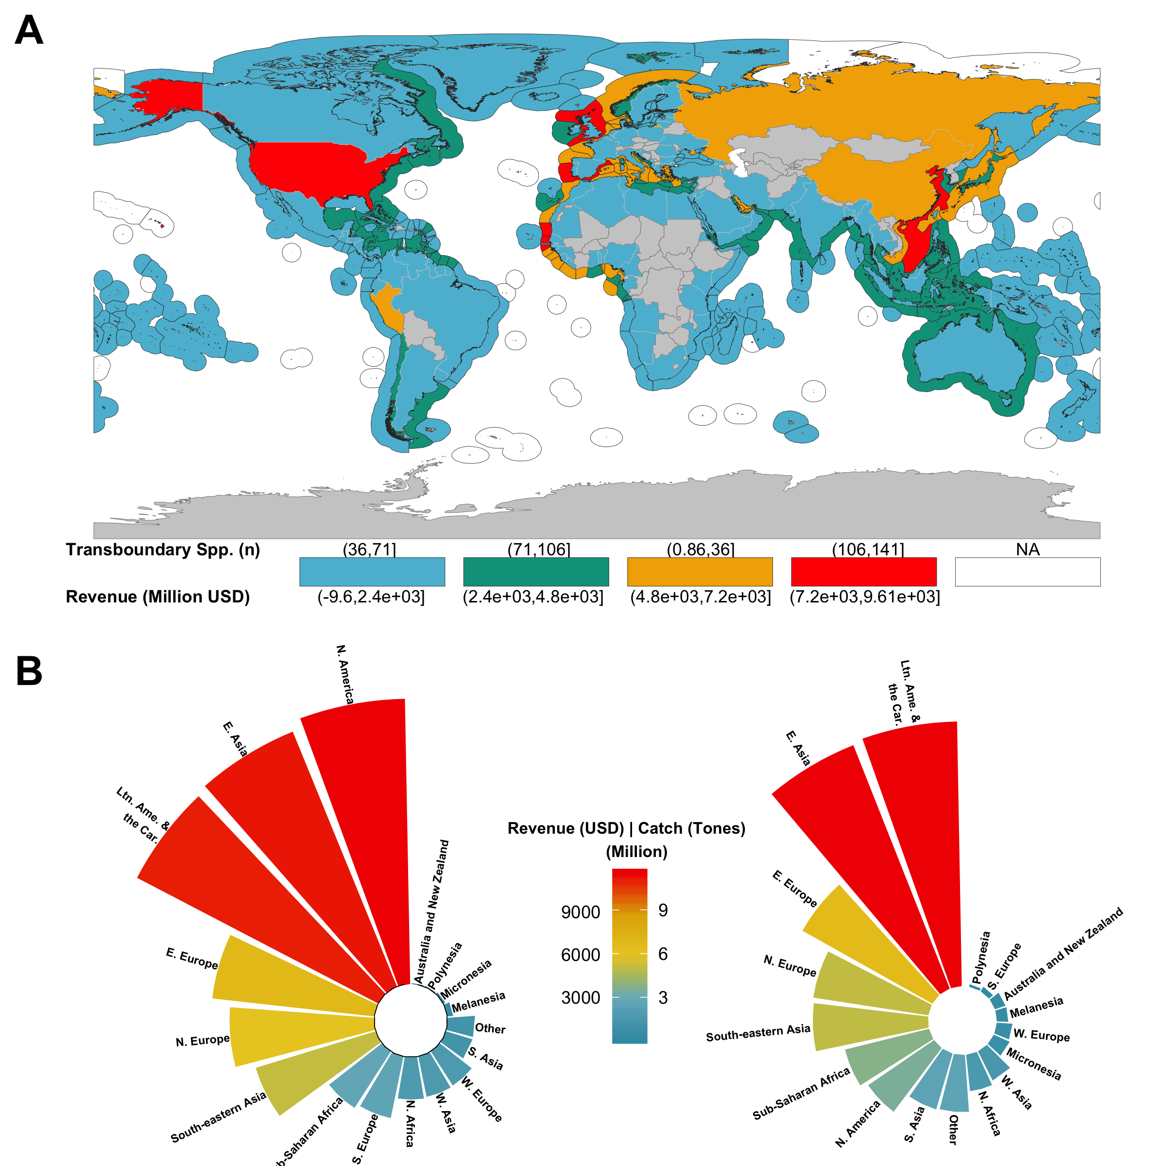

A) Number of transboundary species per EEZ and they contribution to countries fishing revenue. The number of species is represented in the EEZ while the revenue is represented in the land polygon. B) Regional revenue (left) and catch (right) contribution of tranbsoundary species.

We found transboundary fisheries to be of substantial economic importance in regions with historic fisheries-related conflicts. The Asian region with a total number of **310** transboundary species contributing **20’.4 million tons** to the region’s total landings and **19.3 billion USD** in revenue has experienced 43.0% of all documented international fisheries conflicts since 2000 [@Spijkers:2019cz]. The European Union, Norway, Iceland, and the Faroe Islands have been at odds over the size and relative allocation of total allowable catches (TACs) for mackerel since 2007 [@Spijkers:2017ij], a species that is transboundary and contributes **xx** to landings and **xx** in revenue to the countries involved in the dispute. The Mediterranean, a region that has experienced conflicts since the 1980s [@Kliot:1989kv], is home to a large number of transboundary stocks contributing over 6 million tones worth over **8 billion USD** to countries along the Sea’s rim. The identification of current transboundary species is a first step towards establishing joint management plans for marine resources [@Link:2010ei], key not only to sustain fisheries over the long term, but also to avoid international conflict.

The two regions of the world that share the most species (the North East and Central Atlantic) have developed quite different approaches to managing shared stocks. In the North East Atlantic, fisheries are managed by the European Union and quotas allocated by species and regulatory area, with some of them (e.g., Iceland and Norway) characterized as having good fisheries management [@Melnychuk:2017gh]. On the other hand, fisheries along the west coast of Africa could benefit from improvements [@Melnychuk:2017gh]. Ironically, this region has long been exploited by foreign fleets, including European, sometimes illegally [@Belhabib:2015bl], with questionable fishing rights systems [@Mills:2004dj], and unfair fisheries agreements [@Kaczynski & Fluharty 2002]. Thus, having joint management plans for shared stocks between neighbors will not be enough to achieve sustainable goal 14, Life Below Water [@SDG]. Countries need to work together towards a more equitable system of global fishing rights.

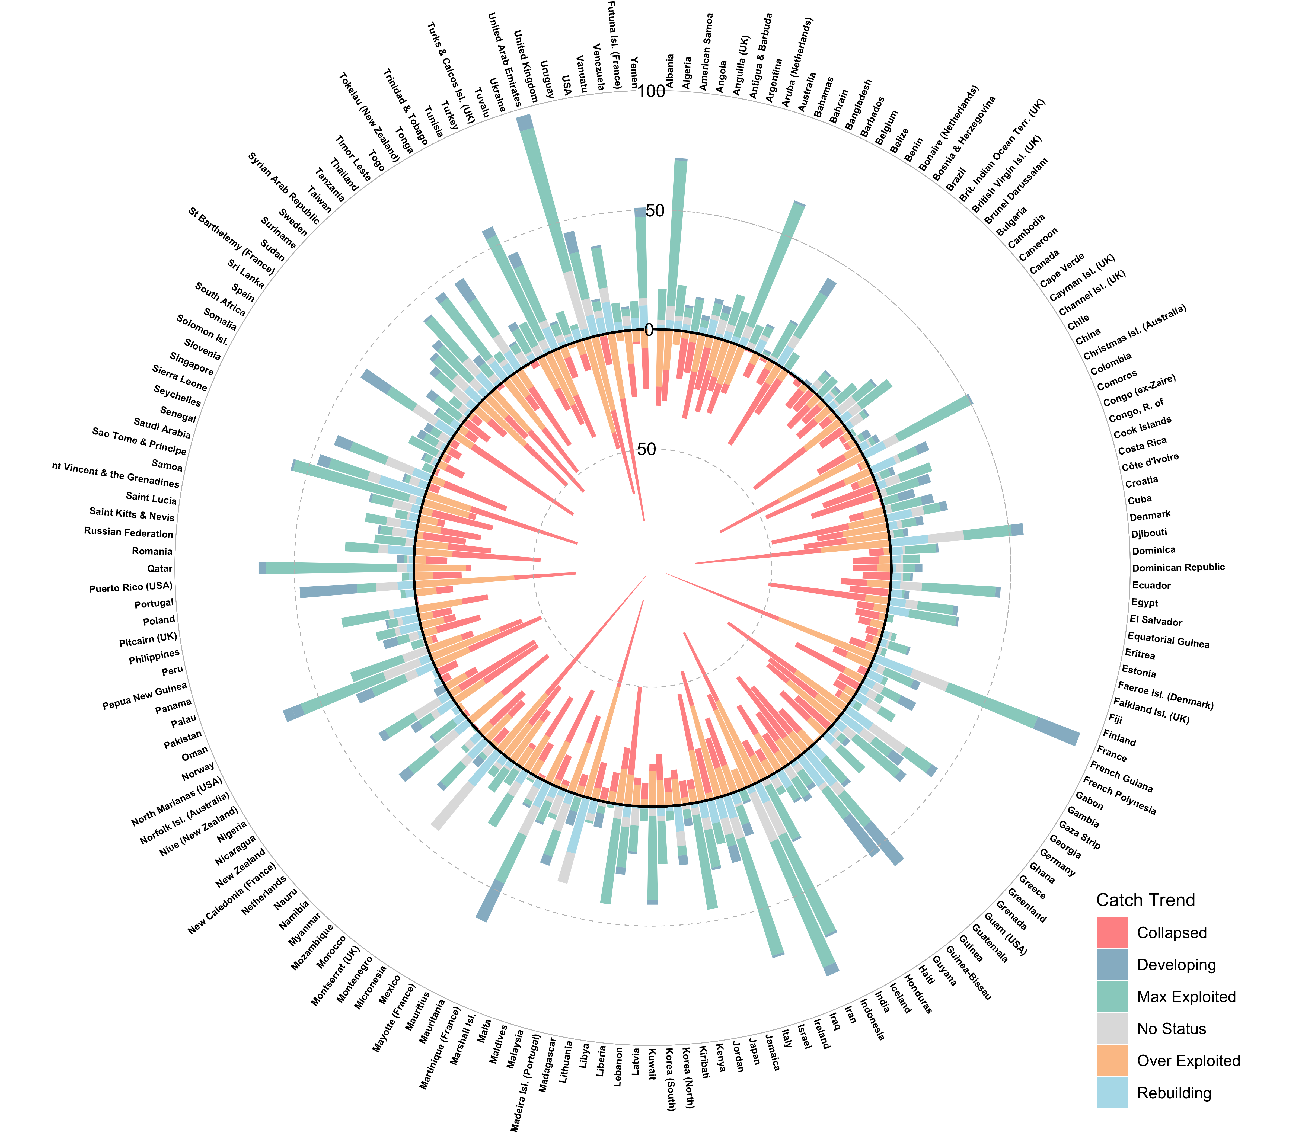

**Number of transboundary and discrete species by country and continent**

Empirical analysis suggest that cooperation will have better outcomes for shared fisheries management. Examples vary between regions and species including Mexico and the United States over Pacific anchovies [@CisnerosMontemayor:2020kv], Norway and Russia over Atlantic cod (*Gadus morhua*)[@Diekert:2010gp], and between Namibia and South Africa over hake (*Merluccius spp*) [@Sumaila:2003vw]. However, few evidence exists today regarding the true efficiency of transboundary fisheries plans. Indeed, there are some successful bilateral management plans for species such as Pacific Halibut between Canada and the US as well [@REference?] and multilateral treaties like the Pacific Nauru Agreement that manages 30% of global skipjack tuna in the South Pacific Islands [@Aqorau:2018bh]. However, the effectiveness of Regional Fisheries Management Organizations, responsible for managing high migratory stocks in areas beyond national jurisdiction, has been previously questioned [@CullisSuzuki:2010fi]. Countries that are today harvesting species at rates less than 50% of the historical maximum catch (Category C) should be paying extra care in these species (Fig. 2). While these catch trends do not reflect stock status [@@Branch:2011br], they could reassemble fisheries that are over exploited or collapsed [@Kleisner:2011wn]. The rebuilding of a transboundary species could be strongly impacted by uncoordinated efforts of countries harvesting the same species but with different objectives [@Ref].

Management of transboundary fisheries needs to be looking forward. As species shift their known distributions to cope with a changing ocean, new transboundary species will arise, challenging the management of shared stocks worldwide [@Pinsky]. Conflicts in regions with a high abundance in transboundary species will likely be exacerbated by climate change, as seen in the ongoing dispute between the European Union, Norway, Iceland and the Faroe Islands over mackerel (**species**) [@Spijkers:2017ij]. Understanding how climate change will affect the biogeography of marine species, and notably the number of countries’ EEZ it spans is a key element to the design of effective long-term spatial-based fisheries management [@Alexa, @Song:2017iua].

Species can have a cosmopolitan distribution, that is, a broader distribution, or be limited to a specific region, known as endemic [@REF]. Maybe not surprisingly, highly migratory pelagic-oceanic species such as Wahoo (*Acanthocybium solandri*), Common thresher shark (*Alopias vulpinus*), and tunas (*Thunnus sp.*) are among the more shared resources in the world with a median of 40 nations sharing these resources. These species are very important in terms of economic value as they (global) average revenue exceeds USDXXX. The median for species of all other ecosystem preferences is close to, or less than, 20, as many of these might be cosmopolitan but not necessarily highly migratory (e.g. *Solea solea*, *Panulirus argus*) (Fig. 3). However, less distributed species must not be ignored. The world of fisheries is highly connected trough larvae dispersal [@Ramesh:2019va] and so, even if a population swims between the borders of two nations, their larvae could be supplying populations thousands of kilometers away [@Ramesh:2019va]. Moreover, many coastal communities, specially in developing regions, and highly dependent on fishing local fish (e.g. reef fish) for food security and improved livelihoods [@CisnerosMontemayor:2016gq; Wabnitz:2018gf].

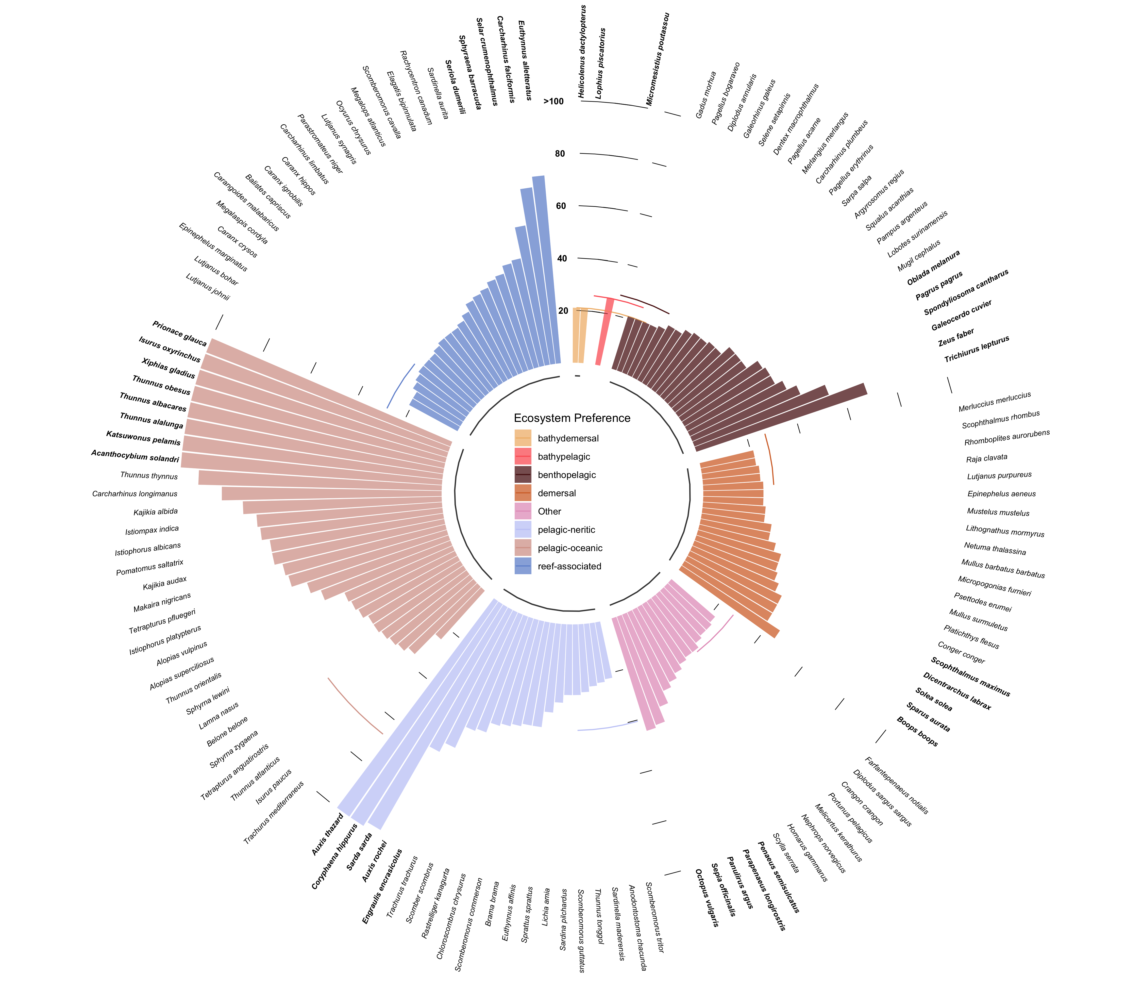

**Number of countries shared by transboundary species. Showing only species that share > 20 countries**

The global contribution of transboundary species to fishing revenue and capture is compelling, with transboundary species playing an important role in many fishing nations. Transboundary species have played and continue to play an important role in fisheries conflicts, with climate change likely to exacerbate this trend given expected shifts in species distribution and the emergence of ‘new’ shared species. Identifying existing transboundary species is the first step towards joint management frameworks that are precautionary, strive for sustainability and can be flexible to accommodate future changes.

# Materials and Methods

We present a novel method to determine whether or not a species can be considered transboundary. The method is based on a series of criteria to be met and the overlay of species distributions and the spatial boundaries of the world’s EEZs. For the current analysis we work at the species level and adopt the Food and consider transboundary species as those that occur within the Exclusive Economic Zone (EEZ) of neighboring countries [@Munro:2002uf; @FAO]. All data was scaled to 0.5 degree latitude x 0.5 degree longitude grid cells (*n* = ~180,000 grid cells).

## Databases on species geographic distributions

To determine the number of transboundary marine species exploited by fisheries within each of the world’s EEZs we first extracted all the commercial marine fish or invertebrate species from the *Sea Around Us* database (<http://www.seaaroundus.org> and determined their current distributions. For this, we used four data sources of species-distributions: (*i*) observational data, (*ii*) an Environmental Niche Model (ENMs), (*iii*) a life-history-based distribution model, and (*iv*) fisheries catch data (**Table x**). Each source represent a different method of estimating the distribution of a given species and thus, provides a more robust result. Only commercial fished species with data from all four sources were included in the analysis. The final dataset comprised **XXX** species, **XX**% of the reported marine species in the SAU database and **XX**% of the reported taxa of the FAO (**See S1_Data**).

### *Occurence data*

The occurrence data was collected from five publicly available repositories; Fishbase (<http://fishbase.org>), the Global Biodiversity Information Facility (GBIF; <https://www.gbif.org/>), the Ocean Biogeographic Information System (OBIS; <https://obis.org/>), the Intergovernmental Oceanographic Comission (IOC; <http://ioc-unesco.org>), and the International Union for Conservation of Nature (IUCN; <https://www.iucn.org/technical-documents/spatial-data>) [@Reygondeau:2019uh].

### *Distribution models*

In addition to the occurrence data we use two different methods to estimate species distributions, hereafter referred as ENM-Nereus and SDM-SAU. Although they use the same data, the models are structurally different complementing each other and providing robustness to the results.

The ENM-Nereus consists in a multimodel approach based on a Bioclim and a Bososted Regression Tree model [@Thuiller:2009gp], a Maxent model [@Phillips:2006ff], and a Non-Parametric Probabilistic Ecological Niche Model [@Beaugrand:2011fd]. Environmental variables utilized in the models included sea surface temperature, surface pH, surface oxygen concentration, and vertically integrated (0–100 m) net primary production (NPP) [@Asch:2018ca]. The ENM-Nereus employed all of the observational data-sources previously mentioned. Global environmental conditions were obtained and results averaged from three Earth System Models developed by the Geophysical Fluid Dynamics Laboratory (GFDL- <https://www.gfdl.noaa.gov/earth-system-model/>), the Institute Pierre Simon Laplace (IPSL- www.icmc.ipsl.fr/), and the Max Planck Institute for Meteorology (MPI- www.mpimet.mpg.de/en/science/models/). See [@Asch:2018ca; @Reygondeau:2019uh] for model details.

The SDM-SAU model follows a five-steps process based on species-specific life history information, rather than environmental variables [@Close:2006ux; @Palomares:wg]. For each commercial fish species, the model first uses the FAO major fishing areas and countries EEZs to determine a broad distribution. It then uses life history information to delimit its range within the FAO fishing area (e.g. thermal preference, depth limits). The range is delimited even further by expert-review polygons and compared with that of AquaMaps [@Kaschner:2016tl], OBIS and GBIF occurrence data. The model then determines a species habitat preference based on the assumptions that the relative abundance of a species is determined by the number of habitats in a grid cell and the distance of the species to each habitat, as well as the importance of the habitat to the species size. Finally, the species equatorial submergence (e.g. the latitudinal region where a species is not seen in between poles) is estimated for each species. See [@Close:2006ux; @Palomares:wg] for model details.

### *Catch data*

The previous models combine observational data with a series of biotic and abiotic information to determine the probability that a species will be found in a given space at a given time. However, this does not mean that the species in question will actually be there. While the models do use approaches to double-check species occurrences (e.g. ENM-Nereus uses four different species distribution algorithms and SPD-SAU undertakes validation by means of other models), we used a fourth data source to corroborate the models’ outputs. The *Sea Around Us* estimates total reconstructed catches - i.e., catches based on all publicly available information sources and including discards, as well as unreported and illegal catches that are not included in the FAO data available for each country. Catches are also spatially allocated [@Zeller2016]. Thus, we used the Sea Around Us catch reconstruction database from 2005 to 2014 (last ten yeares of data) as the fourth dataset to estimate transboundary species and to estimate their catch contribution within EEZs (average 2005-2014).

## Determine if a species is transboundary

We developed a four-criteria method for determining whether or not a species was transboundary. Only species that meet all criteria were considered as transboundary species and the analysis was done only within the EEZs of coastal states. In some cases, criteria also work as indexes to measure the uncertainty in the analysis as they provided continuos index (e.g. from 0 to 1) rather than a discrete, yes or no, index . All of the analysis was done in the statistical software *R version 3.5.2 (2018-12-20)* with the pacages *tidiverse*[@],*data.table*[@],*wesanderson*[@],*janitor*[@],*spdep*[@], *sf*[@],*sp*[@],*rgdal*[@],*tools*[@],*parallel*[@],*rfishbase*[@],*zoo*[@]. All code is available at <https://github.com/jepa/FishForVisa>.

### Criteria 1; Neighboring EEZs

As previously mentioned, we define transboundary species as those marine species that happen within the EEZs of two or more neighboring countries. Hence, the first criteria was that the species would only be transboundary between two neighboring countries, regardless of the species extended distribution. This way, a species such as Atlantic cod (*Gadus morhua*) distributed along the north Atlantic, was only considered transboundary between each of the neighboring nations covering its distribution, rather than the region as a whole. We assume that this would reduce the differences between species and stock as is more likely that neighboring species belong to the same stock, rather than, lets say, Cod in Norway and Canada. However, the analysis here presented was kept at the species level and stocks within countries were not considered.

We define the EEZ boundaries using the SAU shapefile (updated 1 July 2015, available from <http://www.seaaroundus.org>) that sub-divides EEZs by regions (e.g. Mexico Pacific and Mexico Atlantic) and determine the intersections between polygons using the *sf* *R* package [@SF:package]. When estimating transboundary species, we filter out those shared by the EEZs sub-regions, and when aggregating by country we only counted the species once, if it appeared in more than one sub-region. Species that were present in EEZs that were non-continental territories neighboring other countries were kept (e.g. Argentina and Falkland Islands), but removed when the non-continental territory belonged to the same nation (e.g. Brazil and Fernando de Noronha).

### Criteria 2; Data agreement

We use the occurrence database, the ENM-Nereus model, and SDM-SAU model to determine the presence of each species within each of the 0.5 x 0.5 grid cells. We computed a *Species Index* by dividing the number of datasets that confirm presence of a species in a grid cell over the total amount of datasets (*n* = 3). The index is unit-less and represents a scale from 0.3 to 1 where 0.3 means only one dataset reports presence of the species in a grid cell and 1 means agreement between all datasets. We selected only those cases where *Species Index* = 1 to get a more conservative estimate of transboundary species (**S1_Map_per_dataset**).

### Criteria 3; Modeling verification

We assume that a species was only present in a given grid-cell if it was reported in the SAU catch database. Therefore, all species that were not reported as caught in any single year between the reference years (1970 to 2000) in a given grid-cell were dropped, regardless of the *Species Index*. The assumption relies in that if a commercial species is projected within any fishing country, such species would have been fished, and thus reported at some period of time, thus validating the models.

### Criteria 4; Spatial distribution

Finally, in order to have a more robust result and do not determine a transboundary species based on the presence in a single 0.5 x 0.5 grid cell within an EEZ, we computed an *Area Index*. The *Area Index* consist in the proportion of the total species distribution within both EEZs that each neighboring EEZ has. We determine that a species would be transboundary if both neighboring EEZs enclosed over 25% of the species joint distribution. Such threshold can be lowered for a more relaxed result or increased for a more conservative estimate (**S2_Hist_per_Treshold**).

## Fisheries trends

We estimated the economic contribution of transboundary species for each country using global ex-vessel price [@Tai2017]. The data includes ex-vessel price from multiple sources and a structured interpolation method (e.g. similar countries, species) to fill in data gaps [@Sumaila:2015uc]. The contribution of transboundary species was done by aggregating the catch of each species that happened within the EEZ of the countries sharing that species. For this study, we did not include catch from areas beyond national jurisdiction. Finally, we use the catch data to determine the exploitation category of each species within a EEZ. Although this method has previously used to estimate stock status [@Grainger:1996tk; @Kleisner:2011wn], the categories presented here are intended to be seen as catch trends, and not status of each species. We only assessed species within each EEZ that had at least ten years of data between the first and last reported landings with at least five consecutive data years. Three categories were drawn from the method depending on the year’s catch, the maximum catch over time and the minimum catch after the catch peak (**Table XX**). Finally, we reported the predominant category over the last ten years of catch data (2004-2014).

```